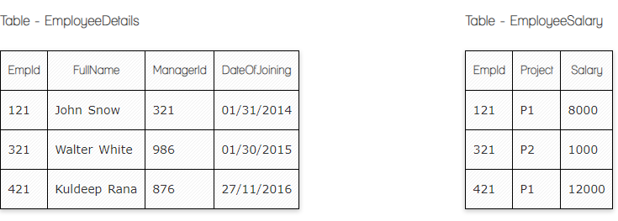

**Ques.1. Write a SQL query to fetch employee names having salary greater than or equal to 5000 and less than or equal 10000.**

**Your Answer:**

Select EployeeDetails.FullName, EployeeSalary.Salary

From EployeeDetails

Inner Join EployeeSalary

On EployeeDetails.Empid= EployeeSalary.Empid

Where EployeeSalary.Salary Between 5000 and 10000

**Ques.2. Write a query to fetch employee names and salary records. Return employee details even if the salary record is not present for the employee.**

**Your Answer:**

Select *, EployeeSalary.Salary

From EployeeDetails

Left Join EployeeSalary

On EployeeDetails.Empid= EployeeSalary.Empid

**Ques.3. Write a SQL query to update EmployeeSalery table with setting Salary to 2000 for Project P2.**

**Your Answer:**

UPDATE EmployeeSalery

SET Salary='2000'

Where Project = 'P2'

**Ques.4. Write a SQL query to right join both tables and draw the results.**

**Your Answer:**

Select EployeeDetails.EmpId, EployeeDetails.FullName, EmployeeSalery.Salary,

FROM EployeeDetails

RIGHT JOIN EmployeeSalery

ON EployeeDetails.Empid= EployeeSalary.Empid

Output should be

|  |  |  |
| --- | --- | --- |
| **EmpId** | **Salary** | FullName |
| 121 | 8000 | John |
| 321 | 1000 | Walter |
| 420 | 12000 | Null |

**Take these two tables:**

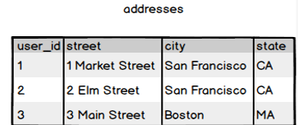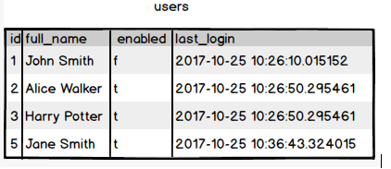

**Ques.5. Write a SQL query to fetch all users full_name who are not from Main street**

**Your Answer:**

Selectaddresses.user_id, addresses.street, users.full_name,

FROM addresses

Inner Join users

ON addresses.user_id = users.id

Where addresses.street Not Like 'Main Street'

**Ques.6. Write a SQL query to fetch all users full_name who are from Main street or San Francisco**

**Your Answer:**

Selectfull_name

FROM users

Inner JOIN addresses

ON addresses.user_id = users.id

Where addresses.street = 'Main Street' or addresses.city ='San Francisco '

**Ques.7. Write a SQL query to fetch user full_name who is equal to user_id from Boston (find user_id value in sub_query)**

**Your Answer:**

Select full_name

From users

Where id in=

(Selectuser_id

FromAddresses

Wherecity= **’**Boston**’**)